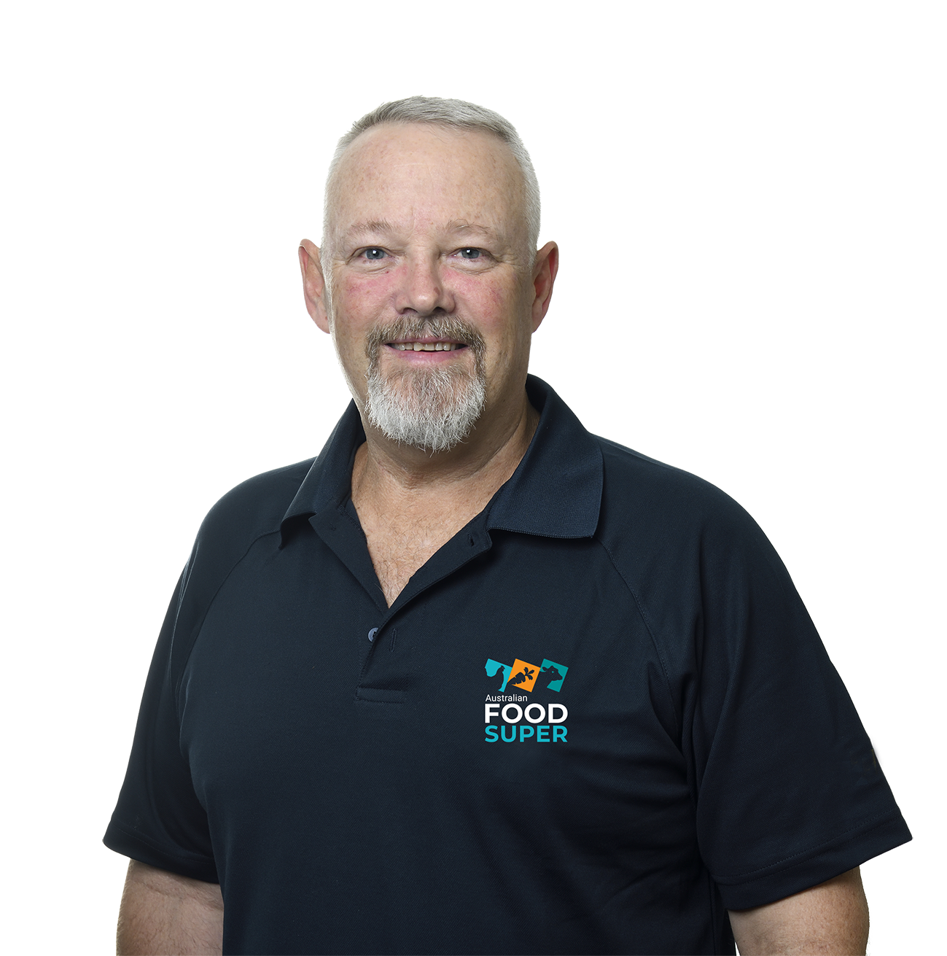

Our Client Services Team
can help you.
Australian Food Super is visiting your worksite
This is your chance to ask us about YOUR super.

Enter Contact Information Here | 1127 Lombard Blvd. San Francisco, CA 59802 | phone 555.555.5555 | fax 555.555.5555

Benefits for members:
- Low fees
- Solid, long-term investment returns
- Automatic insurance for eligible members
- Financial advice over the phone
- Personal service

The Midfield Group
Lunchroom
Wed 10th Sept &
Thurs 11th Sept
From 8am-1pm
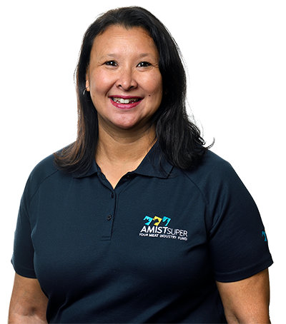
Glen
COME AND TALK WITH US | AMIST Super Hotline | 1800 808 614

